Experiment No.: 07

Experiment Name: Implementation of Curve Fitting Methods (Polynomial Least Square).

Theory: Curve fitting is a fundamental technique in data analysis used to model the relationship between a dependent variable y and an independent variable x. The objective is to find a mathematical function that best represents the observed data. In polynomial curve fitting, the model assumes that y can be approximated by a polynomial of degree n:
$$y= a_{0}+a_{1}x+a_{2}x^{2}+…+a_{n}x^{n}$$

The coefficients a₀​, a₁, …, a_{n}​ are determined using the Least Squares Method, which minimizes the sum of the squared differences between the observed data points and the values predicted by the model. Mathematically, the goal is to minimize:

$$S=\sum_{i=1}^{n}{{\left[y_{i}- \left(a_{0}+a_{1}x_{i}+a_{2}x_{i}^{2}+…+a_{n}x_{i}^{n}\right)\right]}^{2}}$$

By differentiating S with respect to each coefficient a_{j}​ and setting the derivatives to zero, a system of n+1 linear equations known as the Normal Equations is obtained. Solving these equations gives the optimal coefficients that define the best-fit polynomial.
In this experiment, we implemented this process manually using NumPy in Python. The sums of powers of x and the products of x^{k} with y were calculated to form the matrix A and vector B of the normal equations, which were then solved using np.linalg.solve() to obtain the coefficients a0,a1,a2​. The fitted polynomial was used to compute predicted y-values (y_{pred}​) for comparison with the given data.
Program:
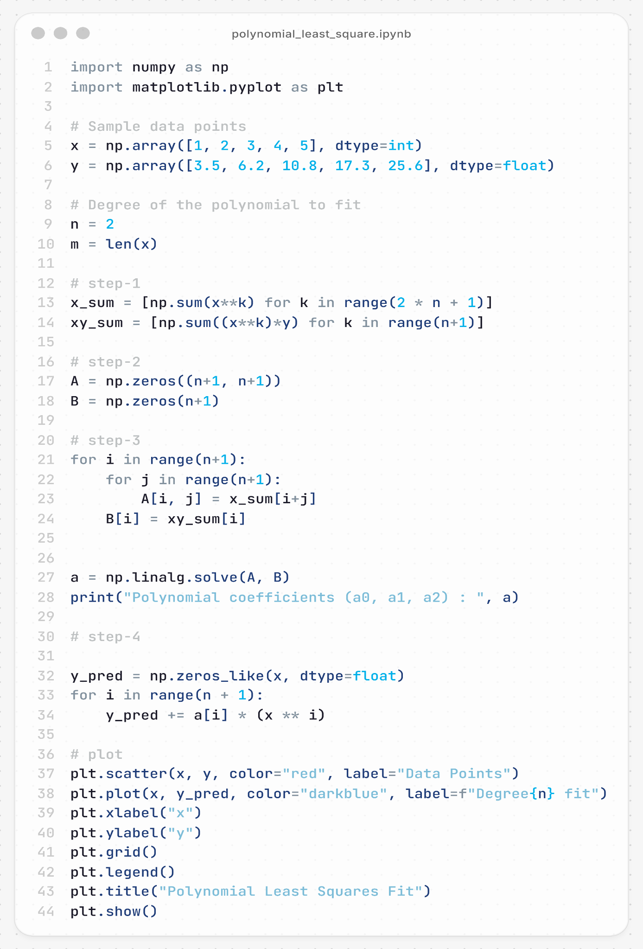

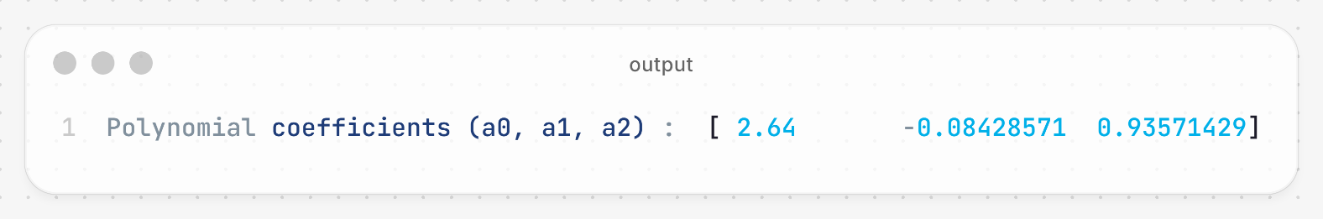
Output:

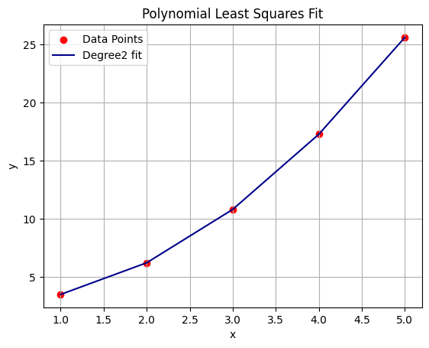

Discussion & Conclusion:
The experiment successfully demonstrated the process of polynomial curve fitting using the least squares method. For the given dataset, a second-degree polynomial (n = 2) was chosen, which provided a smooth and accurate approximation of the nonlinear data trend. The computed coefficients a0, a1, a2 define the best-fit quadratic equation that minimizes the total fitting error. In conclusion, the Polynomial Least Squares Method provides a powerful and mathematically sound approach to model nonlinear data. This implementation not only reinforces the theoretical understanding of curve fitting but also demonstrates the practical application of linear algebra and numerical methods in data modeling using Python.

